**Industrial Internship Report on**

**”Quality Prediction in a Mining Process”**

**Prepared by**

**Vishesh Tamrakar**

**Surbhi Parganiha**

|  |
| --- |
| *Executive Summary* |
| This report provides details of the Industrial Internship provided by upskill Campus and The IoT Academy in collaboration with Industrial Partner UniConverge Technologies Pvt Ltd (UCT).  This internship was focused on a project/problem statement provided by UCT. We had to finish the project including the report in 6 weeks’ time.  My project was quality prediction of real time industrial data of the mining process from a flotation plant. The main goal was to use this data to predict how much impurity is present in the ore concentrate. As this impurity is measured every hour, if we can predict how much silica (impurity) is in the ore concentrate then we can help the engineers and give them early information to take actions (empowering!). Hence, they will be able to take corrective actions in advance (reduce impurity, if it is the case) and also help the environment (reducing the amount of ore that goes to tailings as you reduce silica in the ore concentrate).  This internship gave me a very good opportunity to get exposure to Industrial problems and design/implement solutions for that. It was an overall great experience to have this internship. |

**TABLE OF CONTENTS**

1 Preface…………………………………………………………………………………………………………………………………………3

2 Introduction………………………………………………………………………………………………………………………………...5

2.1 About UniConverge Technologies Pvt Ltd…………………………………………………………………………5

2.2 About upskill Campus.……………………………………………………………………………………………………..9

2.3 The IoT Academy……………………………………………………………………………………………………………10

2.4 Objective.………………………………………………………………………………………………………………………10

2.5 Reference.……………………………………………………………………………………………………………………..10

2.6 Glossary…………………………………………………………………………………………………………………………11

3 Problem Statement…………………………………………………………………………………………………………………….11

4 Existing and Proposed solution……………………………………………………………………………………………………12

4.1 Code submission…………………………………………………………………………………………………………………..13

4.2 Report submission………………………………………………………………………………………………………………..13

5 Proposed Design/ Model…………………………………………………………………………………………………………….14

5.1 High Level Diagram…………………………………………………………………………………………………….….26

6 Performance Test……………………………………………………………………………………………………………………….26

6.1 Test Plan/ Test Cases.……………………………………………………………………………………………………..26

6.2 Test Procedure……………………………………………………………………………………………………………….27

6.3 Performance Outcome…………………………………………………………………………………………………..27

7 My learnings……………………………………………………………………………………………………………………………….27

8 Future work scope………………………………………………………………………………………………………………………27

**1** **Preface**

This whole internship program provided by UpSkill Campus was full of valuable information and knowledge which helped us to develop fundamental insight about the various topics which are essential in the field of Computer Science such as

* Big Data and its impacts.
* Machine Learning and its applications.
* Information about Data Analyst, Data Scientist & Data Engineer.
* Guidance for interview preparation.

We required an opportunity to work on a real time industrial data project where we could help manufacturing plants to be more efficient and that is what this internship from UpSkill Campus provides to us. This internship allowed us to expand our knowledge and practices to be able to contribute to real world problems thereby encouraging us to acquire the necessary skills hence to develop skills that are essential in career development.

With the help of the provided dataset from a flotation plant of a mining plant our main goal is to use this data to predict how much impurity is in the ore concentrate. As this impurity is measured every hour, if we can predict how much silica (impurity) is in the ore concentrate, we can help the engineers, giving them early information to take actions. Hence, they will be able to take corrective actions in advance (reduce impurity, if it is the case) and also help the environment (reducing the amount of ore that goes to tailings with the reduction of silica in the ore concentrate). Hence We decided to work upon this Industrial manufacturing and production problem by using machine learning algorithms to perform the necessary predictions.

We formed various inferences which are as follows:

* % Silica Concentration in every minute
* % Silica Concentration forecast time calculation
* Prediction of % Silica concentrate with and without using % iron concentrate column

Deep learning approach using LSTM was implemented to forecast gangue content in flotation concentrate. In this approach we also used regression models and loss as evaluation metric so as to obtain results based upon the trained models to find the % Silica in every minute.

Excluding % iron in concentrate from the features, % silica in concentrate were forecasted one hour ahead and with error below 1 (based on RMSE, MAE). As per the dataset MAE and RMSE of 1±0.2 is a satisfactory result. The forecasts thus show a promising method for the engineers to make timely assessments of concentrated purity and take corrective actions in advance, especially when purity deviates from the acceptable values.

Hence Yes, It is possible to predict % Silica in Concentrate without using % Iron Concentrate column.But here we also observe that the R^2 value with inclusion of % Iron Concentrate column is greater that when not included that means it did really helped in the prediction because of the high correlation between them.

This internship program was planned for a period of six weeks where we were provided with a list of projects to choose from and work towards it till the end of the course. There were also weekly tasks such as weekly report submission in which we had to describe the progress on the project and the obstacles which had to be overcome. UpSkill Campus organized quizzes biweekly ( i.e. 2nd, 4th & 6th week ) which tested our skills over the concepts of data science and machine learning.

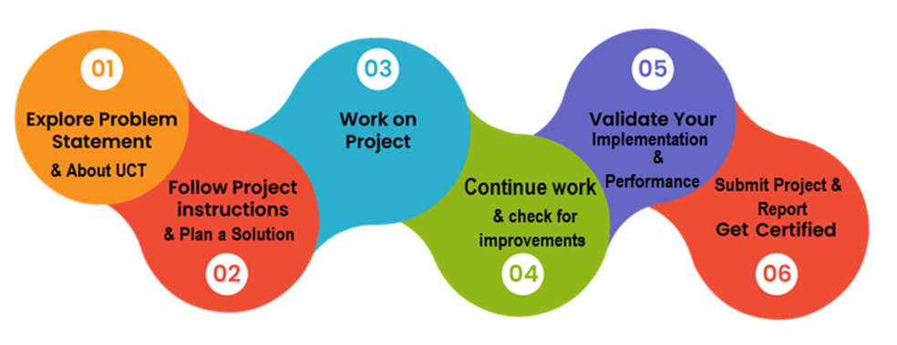

Overall our experience was filled with exhilaration towards learning something new, applying them and overcoming the challenges faced throughout the course of internship.

I would like to thank Nitish Sharma Sir, Kaushlendra Singh Sisodia Sir and Tushar Mehra Sir for instructing and constantly guiding us about the deadline of report submissions and quizzes and thereby helping us throughout the internship program.

A message to my juniors and peers is to stick with the schedule throughout the course of this internship and no issues or barriers will come in your journey towards completion of the course and if you have any queries the mentors are always there to help.

# 

# **2** **Introduction**

## **2.1** **About UniConverge Technologies Pvt Ltd**

A company established in 2013 and working in the Digital Transformation domain and providing Industrial solutions with prime focus on sustainability and RoI.

For developing its products and solutions it is leveraging various **Cutting Edge Technologies e.g. Internet of Things (IoT), Cyber Security, Cloud computing (AWS, Azure), Machine Learning, Communication Technologies (4G/5G/LoRaWAN), Java Full Stack, Python, Front end** etc.



**i. UCT IoT Platform ()**

**UCT Insight** is an IOT platform designed for quick deployment of IOT applications at the same time providing valuable “insight” for your process/business. It has been built in Java for backend and ReactJS for Front end. It has support for MySQL and various NoSql Databases.

* It enables device connectivity via industry standard IoT protocols - MQTT, CoAP, HTTP, Modbus TCP, OPC UA
* It supports both cloud and on-premises deployments.

It has features to

* Build Your own dashboard
* Analytics and Reporting
* Alert and Notification
* Integration with third party application(Power BI, SAP, ERP)
* Rule Engine

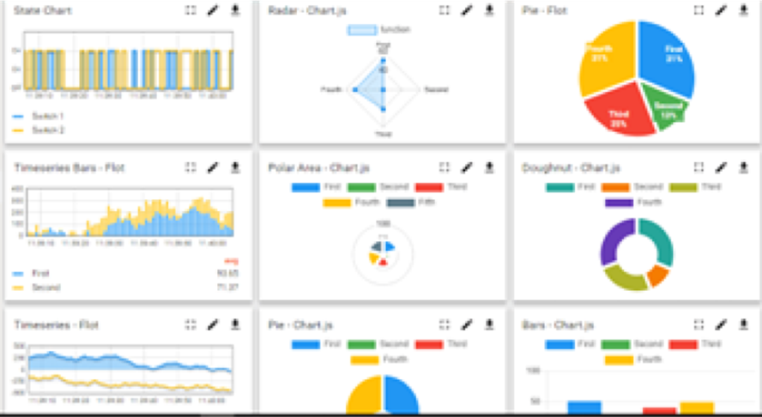

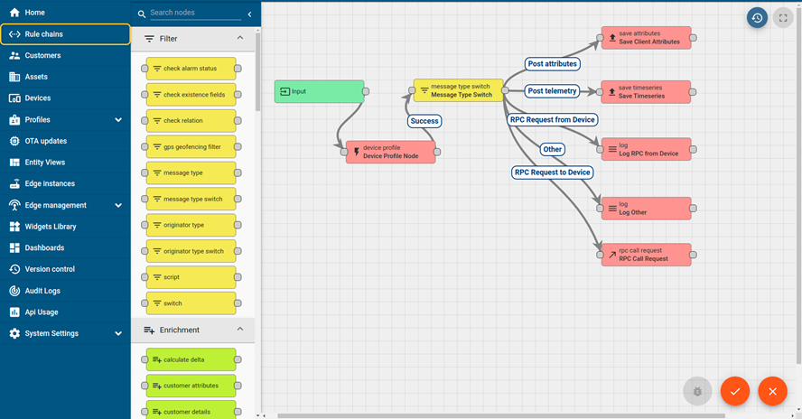

**ii.** **Smart Factory Platform (** **)**

Factory watch is a platform for smart factory needs.

It provides Users/ Factory

* With a scalable solution for their Production and asset monitoring
* OEE and predictive maintenance solution scaling up to digital twin for your assets.
* To unleash the true potential of the data that their machines are generating and helps to identify the KPIs and also improve them.
* A modular architecture that allows users to choose the service that they want to start and then can scale to more complex solutions as per their demands.

Its unique SaaS model helps users to save time, cost and money.

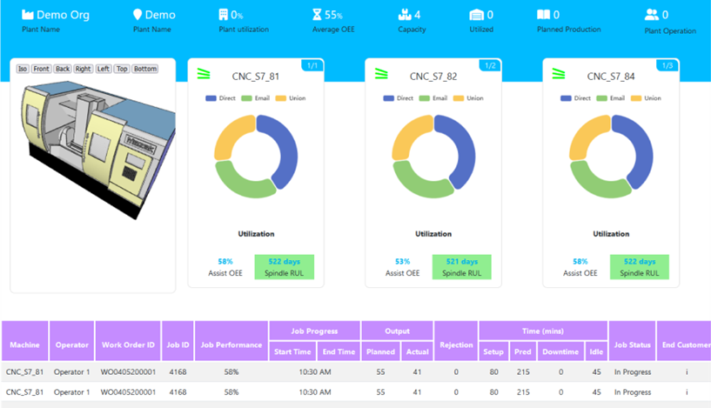

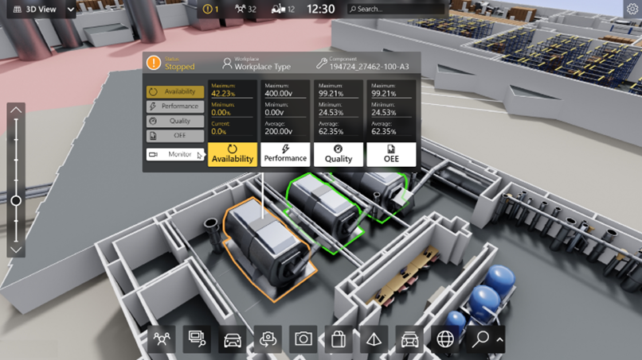

**iii.based Solution**

UCT is one of the early adopters of LoRAWAN technology and provides solutions in Agritech, Smart cities, Industrial Monitoring, Smart Street Light, Smart Water/ Gas/ Electricity metering solutions etc.

**IV. Predictive Maintenance**

UCT is providing Industrial Machine health monitoring and Predictive maintenance solution leveraging Embedded system, Industrial IoT and Machine Learning Technologies by finding Remaining useful life time of various Machines used in production process.

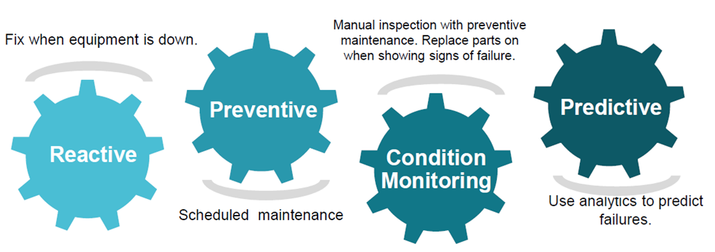

## 

## **2.2 About upskill Campus (USC)**

Upskill Campus along with The IoT Academy and in association with Uniconverge technologies has facilitated the smooth execution of the complete internship process.

USC is a career development platform that delivers **personalized executive coaching** in a more affordable, scalable and measurable way.

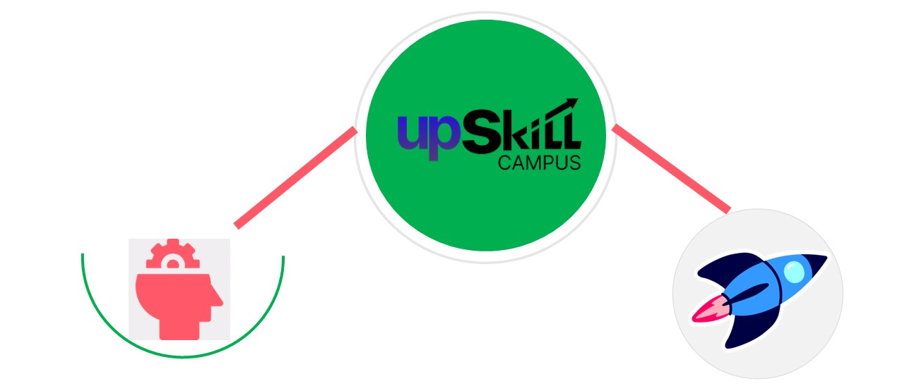

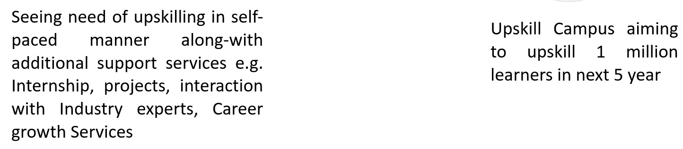

<https://www.upskillcampus.co/>

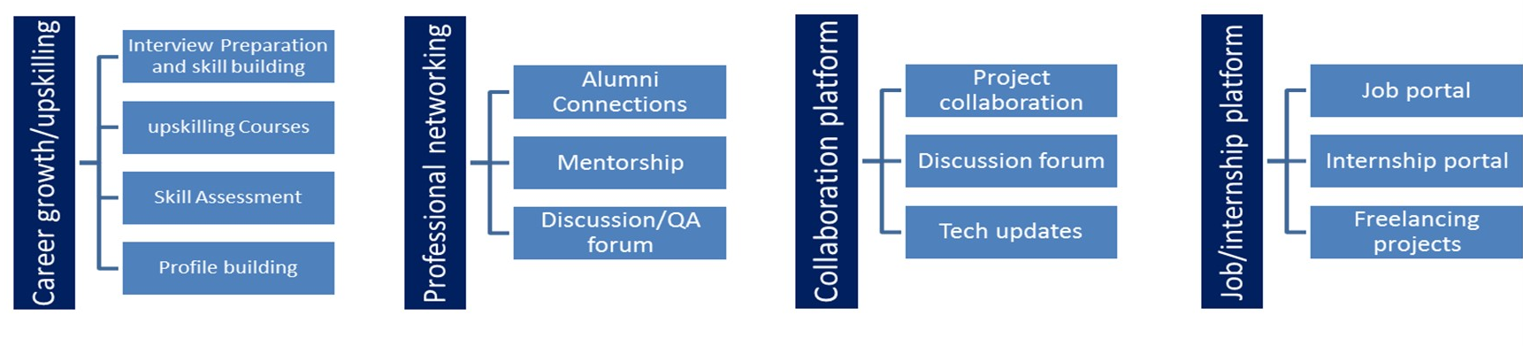

**2.3 The IoT Academy**

The IoT academy is the EdTech Division of UCT that is running long executive certification programs in collaboration with EICT Academy, IITK, IITR and IITG in multiple domains.

**2.4** **Objectives of this Internship program**

The objective for this internship program was to

* Get practical experience of working in the industry.
* To solve real world problems.
* To have improved job prospects.
* To have Improved understanding of our field and its applications.
* To have Personal growth like better communication and problem solving.

**2.5 Reference**

[1] Galit Shmueli. (2018). Data mining for business analytics : Concepts, techniques, and applications in R. Hoboken, New Jersey: John Wiley & Sons, Inc

[2] Nakhaei, F., & Irannajad, M. (2015). Application and comparison of RNN, RBFNN and MNLR approaches on prediction of flotation column performance. International Journal of Mining Science and Technology, 25(6), 983–990.

[3] Pabst, A. (1970). A Dictionary of Mining, Mineral, and Related Terms. Mineralogical Magazine, 37(289), 635–636.

[4] Bergh, L. G., & Yianatos, J. B. (2011). The long way toward multivariate predictive control of flotation processes. Journal of Process Control, 21(2), 226–234.

**2.6** **Glossary**

|  |  |
| --- | --- |
| **Terms** | **Acronym** |
| UCT | UniConvergence Technologies Private Limited |
| USC | UpSkill Campus |
| RMSE | Root Mean Square Error |
| MAE | Mean Absolute Error |
| LSTM | Long Short-Term Memory |
| RNN | Recurrent Neural Network |
| IDS | Intrusion Detection Systems |

**3 Problem Statement**

The main goal is to use this data to predict how much impurity is in the ore concentrate. As this impurity is measured every hour, if we can predict how much silica (impurity) is in the ore concentrate, we can help the engineers, giving them early information to take actions. Hence, they will be able to take corrective actions in advance (reduce impurity, if it is the case) and also help the environment (reducing the amount of ore that goes to tailings with the reduction of silica in the ore concentrate). Hence We decided to work upon this Industrial manufacturing and production problem by using machine learning algorithms to perform the necessary predictions.

The dataset was obtained from a mineral processing plant separating silica from iron ore using the reverse cationic flotation method. Continuous process data were collected from 1 a.m. on March 10, 2017 to 11 p.m. on September 9, 2017. Each row of data consists of 23 measurements that can be categorized into four types:

* Raw materials (column 2-3);
* Environment variables (column 4-8);
* Process variables (column 9-22);
* Processed materials (column 23-24).

Raw materials and processed materials were sampled on an hourly basis while the others were sampled every 20 seconds

The first column shows time and date range (from march of 2017 until september of 2017). The second and third columns are quality measures of the iron ore pulp right before it is fed into the flotation plant. Column 4 until column 8 are the most important variables that impact the ore quality at the end of the process. From column 9 until column 22, we can see process data (level and air flow inside the flotation columns, which also impact ore quality. The last two columns are the final iron ore pulp quality measurement from the lab.

The expected outputs in the submission are as follows :

* Is it possible to predict % Silica Concentrate every minute?
* How many steps (hours) ahead can we predict % Silica in Concentrate? This would help engineers to act in a predictive and optimized way, mitigating the % of iron that could have gone to tailings.
* Is it possible to predict % Silica in Concentrate without using % Iron Concentrate column (as they are highly correlated)?

**4 Existing and Proposed solution**

In practice, management metallurgists and control operators bank on laboratory tests to take ad-hoc decisions for corrective action in order to achieve optimal quality of ore recovery in the froth flotation system. Usually, the laboratory analysis takes two or more hours to ascertain the two variables of interest, which are the percentage of iron ore and silica concentrate. Such practice however, has demonstrated to be a non-novel technique to monitor and control the global unit circuit of the froth flotation system. In addition, the concomitant variation in the ore feed coupled with output stipulation changes make it cumbersome to put the plant in a steady state as a result of lengthy delays of the laboratory test. This includes reduction of ore feed rate or increasing or decreasing the reagents flow or air flow.

Although researchers have studied numerous different techniques on how to find a lasting solution to circumvent this relatively efficient way of liberating gangue particles given a measurable input, little efforts have been made to estimate the percentage of silica concentrate in real-time. More importantly, the silica concentrate is often quite susceptible to estimation error especially when it would end up in the tailings. Another problem worth mentioning is that the company's losses are a colossal amount of money each fiscal year as chucks of quality ore recovery end up in the tailings. There is therefore the need to derive models for efficient predictions that would incorporate all the stochastic nature of a flotation plant so as to build a reliable platform for decision making in real-time.

In our attempt we used different methods of supervised machine learning predictive models performance using the froth flotation processing plant dataset. Python Statistical capacities for modeling would be applied on the data however, physical characteristics of froth such as bubble shape, speed, size distribution and colors were not considered as model input parameters. Preliminary analysis was carried out to understand the global landscape of the dataset. By summarizing the data we generated detailed statistics of the dataset. The aim was to assess skewness of each variable and detect outliers.

Data visualization and analyzing techniques were used to understand the correlation between the variables of the provided dataset and the building of models which also constituted splitting and scaling of the data into training, validation and testing sets.

The machine learning algorithms which we used are as follows :

**Linear Regression :** Linear regression is one of the easiest and most popular Machine Learning algorithms. It is a statistical method that is used for predictive analysis. Linear regression algorithm shows a linear relationship between a dependent (y) and one or more independent (y) variables, hence called linear regression. Since linear regression shows the linear relationship, which means it finds how the value of the dependent variable is changing according to the value of the independent variable.

**Long Short-Term Memory (LSTM) :** Long short-term memory (LSTM) is an artificial recurrent neural network (RNN) architecture used in the field of deep learning. Unlike standard feedforward neural networks, LSTM has feedback connections. It can not only process single data points (such as images), but also entire sequences of data (such as speech or video). For example, LSTM is applicable to tasks such as unsegmented, connected handwriting recognition,speech recognition and anomaly detection in network traffic or IDS’s (intrusion detection systems).

**Random Forest :** This method basically trains a number of classifying decision trees on various different subsamples. It benefits from an averaging mechanism to improve the predictive accuracy and to control over-fitting. Training samples are randomly selected with replacement. The size of each new training set is the same as the original dataset. That is to say, a chosen instance is likely to be chosen again and again as an element of distinct subsets. As input parameters, the number of trees in the algorithm and maximum depth should be determined initially. The change in their values may affect the performance and predictive power of the algorithm. Therefore, all possible parameters in the range for the size of the dataset are given to the method and tested. The parameters leading to best results become candidates to be used. This method performs efficiently without causing too much computational cost.

**4.1 Code submission (Github link)**

<https://github.com/Vishesh-tamrakar/UpSkill-Campus/blob/main/QualityPredictionInAMiningProcess_VisheshTamrakar_USC_UCT.ipynb>

**4.2 Report submission (Github link)**

<https://github.com/Vishesh-tamrakar/UpSkill-Campus/blob/main/QualityPredictionInAMiningProcess_VisheshTamrakar_USC_UCT.docx>

# 

# 

# **5 Proposed Design/ Model**

**OBSERVATION**

The dataset was obtained from a mineral processing plant separating silica from iron ore using the reverse cationic flotation method. Continuous process data were collected from 1 a.m. on March 10, 2017 to 11 p.m. on September 9, 2017.

Each row of data consists of 23 measurements that can be categorized into four types:

* Raw materials (column 2-3);
* Environment variables (column 4-8);
* Process variables (column 9-22);
* Processed materials (column 23-24).

Raw materials and processed materials were sampled on an hourly basis while the others were sampled every 20 seconds

The first column shows time and date range (from march of 2017 until september of 2017). The second and third columns are quality measures of the iron ore pulp right before it is fed into the flotation plant. Column 4 until column 8 are the most important variables that impact the ore quality at the end of the process. From column 9 until column 22, we can see process data (level and air flow inside the flotation columns, which also impact ore quality. The last two columns are the final iron ore pulp quality measurement from the lab.

Preliminary analysis was carried out to understand the global landscape of the dataset. By summarizing the data we generated detailed statistics of the dataset. The aim was to assess skewness of each variable and detect outliers. It was realized that all variables were stored as numeric with the exception of the date variable which was stored as a factor.

The major python libraries and their components which were required throughout the functioning of the project are numpy, pandas, seaborn, matplotlib.pyplot, re, tensorflow, sklearn and IPython.

**% SILICA CONCENTRATION EVERY MINUTE**

In the dataset we have to predict the % Silica Concentrate and it is the impurity in the iron ore which needs to be removed. The current process of detecting silica takes many hours so with the help of some analysis and modeling of data we can give a good approximation of silica concentrate which will reduce a lot of time and effort required for processing iron ore.

A correlation analysis was employed in this study to examine if explanatory variables share the same linear relationship with the outcome variable in order to detect duplications of variables in the dataset. Amongst other things, highly correlations between variables were observed in the dataset. The Pearson correlation coefficient r, takes a range of values between +1 to -1. A value of 0 indicates that there is no relationship between the two variables. A value less than zero indicates a negative relationship and a value greater than zero connotes a positive association: that is, as one unit of variable increases, so does the value of the other variable.

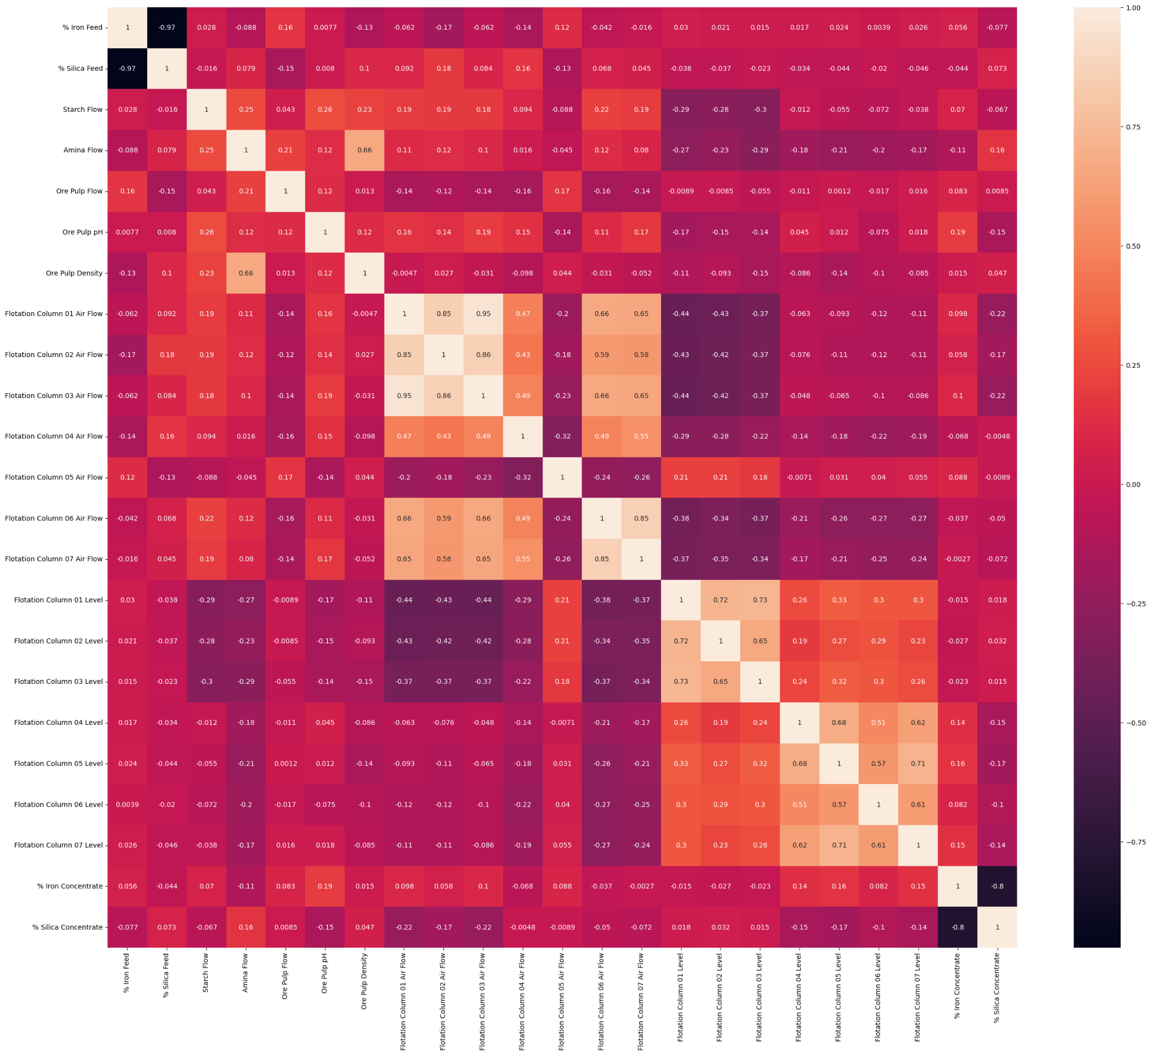

The plot above shows the correlations between the features hence from this list we can find out the features which affect the % Silica Concentrate and discard the ones which are least important.

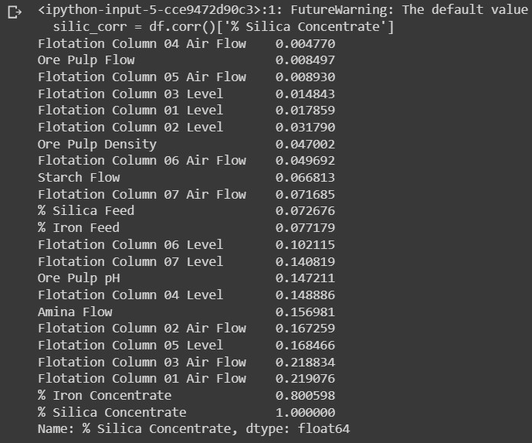

Later we performed scaling and splitting the data which was followed by training of the models X_train and Y_train with test_size=0.3 of X_test and Y_test

Using the method of linear regression the mean squared error was calculated to be 0.4104081859981587 whereas when using the method of Stochastic Gradient Descent the mean squared error was calculated to be 0.4107446893718991

A model was constructed using the RandomForestRegressor that takes 15-20 minutes to provide with an output which is further used with regression models and loss as evaluation metric so as to obtain results based upon the trained models in the form of a plot shown below.

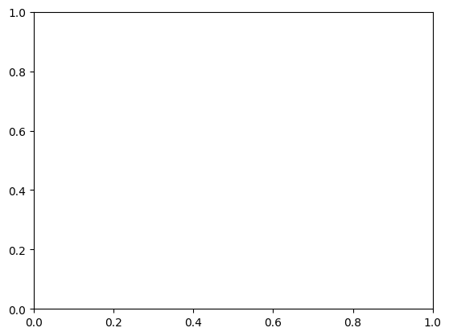

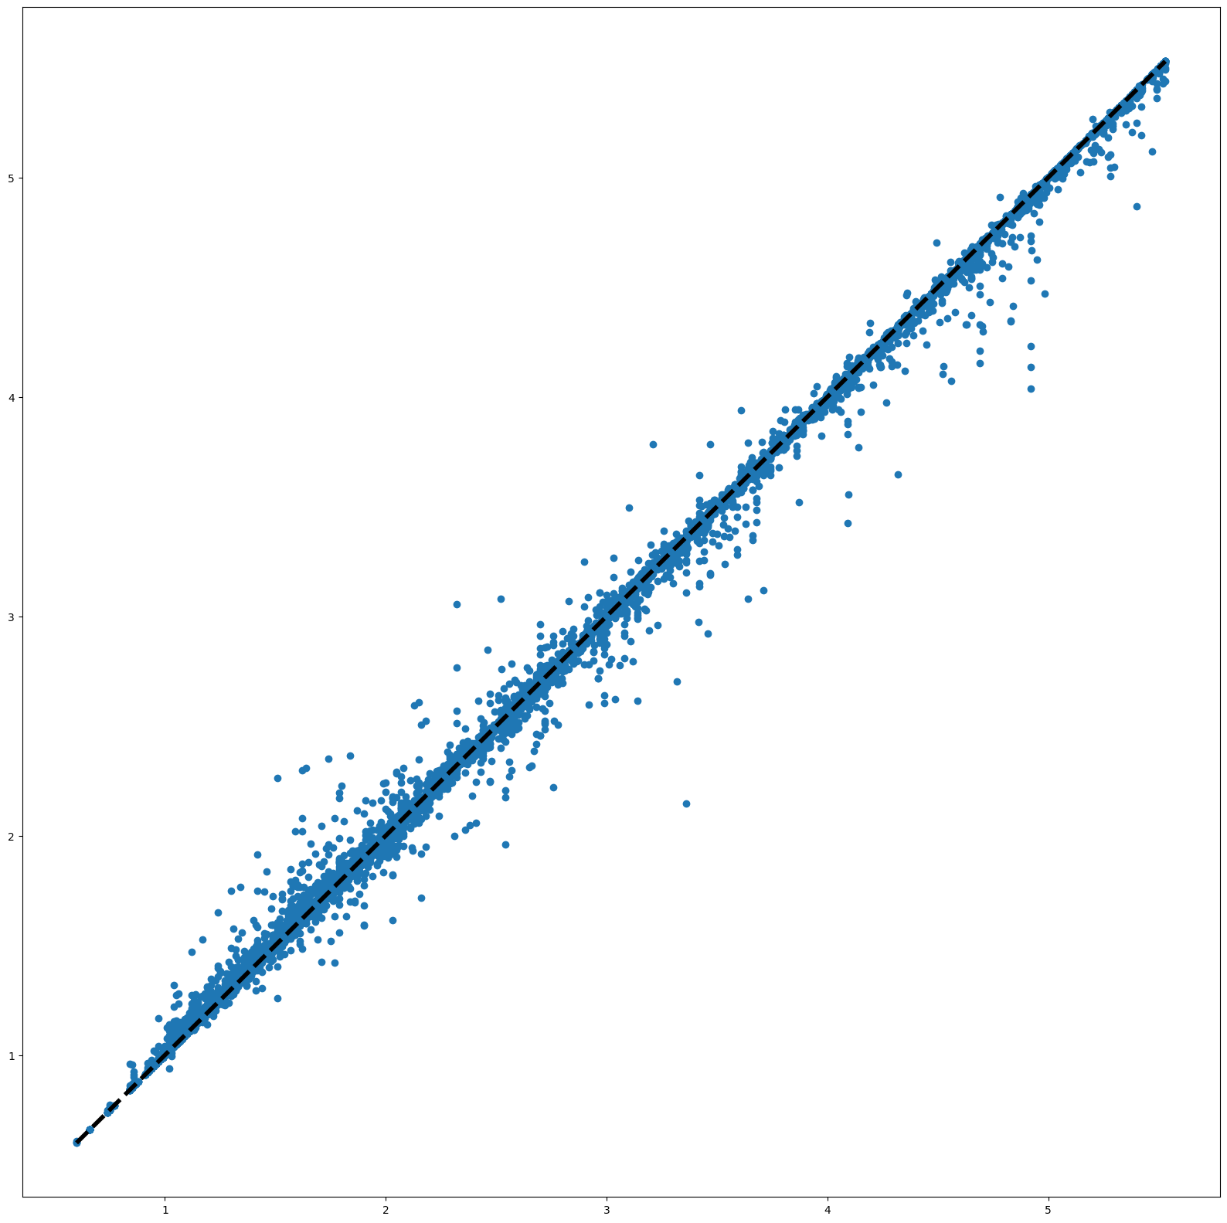

**% SILICA CONCENTRATION FORECAST TIME CALCULATION**

Importing the provided dataset with the help of the github repository url and changing the column names so as to make the dataset easier to interpret thereby also replacing the “ , “ symbol to “ . “ symbol for our understanding and computations and column date is resampled to reduce the frequency of our time-series data into an hourly basis. This is achieved by selecting only the first measurements of each hour thus we looked into the preliminary information regarding the data set such as range, data type and memory usage before proceeding towards the operations of preprocessing.

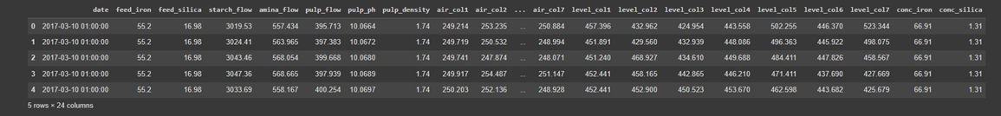

Upon inspecting the data, 318 rows containing missing values are found between 2017-03-16 06:00 to 2017-03-29 11:00. Missing values may introduce discontinuity in the time-series data which may result in detrimental to our forecast. Therefore, only the data starting from 2017-03-29 12:00 will be used further.

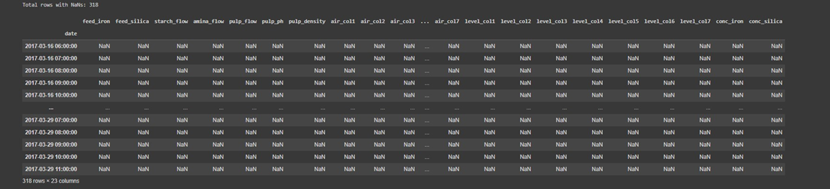

The following plot shows mineral content before (i.e., in the feed) and after the flotation process (in the concentrate). As can be observed from the figure, the purpose of flotation is to increase recovery of iron minerals while reducing the gangue (silica).

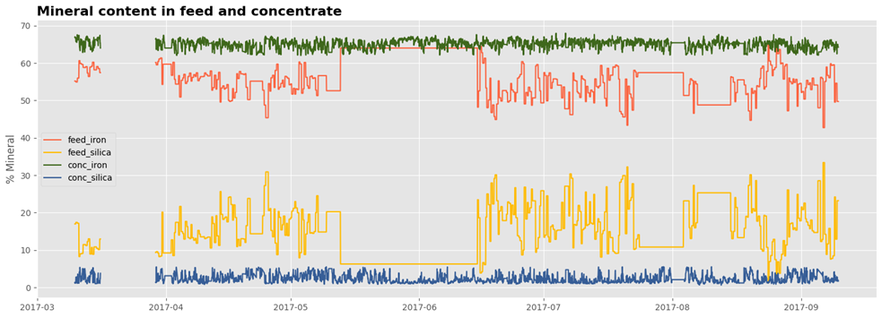

During some periods (e.g., May 13 to June 13), mineral content in the feed was constant but the resulting content in the concentrate fluctuated. This suggests that % iron and % silica in concentrate are not solely governed by the content of raw materials but other parameters as well (i.e., environment, process variables).

The column conc_iron is dropped from the dataframe because we want to look at forecasting % silica in concentrate without including % iron in concentrate as a feature. The data are then normalized as they have different units and scales.

Here the preprocessing stage involves framing the dataset as a supervised learning problem where we forecast the % silica in concentrate at the current hour (t) given the parameters (i.e., raw materials, environment, process) in prior time steps (t-n). We transform the dataset using the series_to_supervised() function.

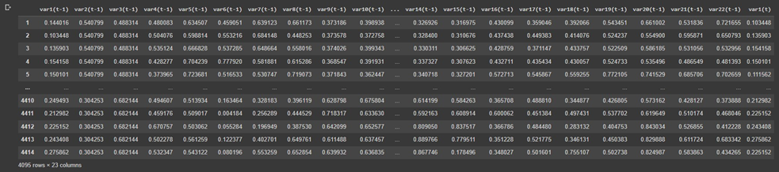

Column var1(t-1) until var22(t-1) are our features/inputs. Measured values of the inputs are lagged 1 hour before the target var1(t) (% silica in concentrate at time t).

Transformed data is further split into three sets: training (60%), validation (20%), and testing (20%). Flotation data in the period between 2017-03-29 12:00 and 2017-08-08 00:00 is used for training/validation purposes, totaling 3157 hours.

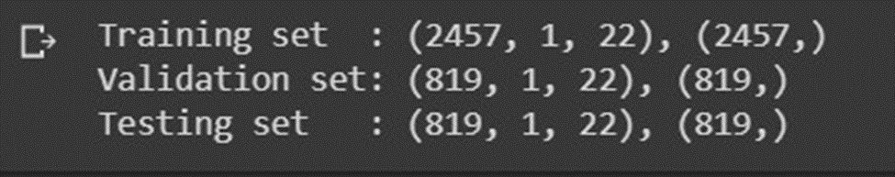

Forecasting gangue present in flotation concentrate is a time-series related problem. A variation of the recurrent neural networks (RNN), called the long short-term memory (LSTM), is a deep learning approach which can be implemented to solve this problem. Model construction and training is done with Keras - a Python deep learning library. The model is made up of two LSTM layers : each with 16 memory cells followed by a fully-connected (Dense) layer.

In training, the data are grouped into mini batches of 16 training samples. The training process is run for 100 epochs (one epoch is the number of passes needed to complete the entire training samples).

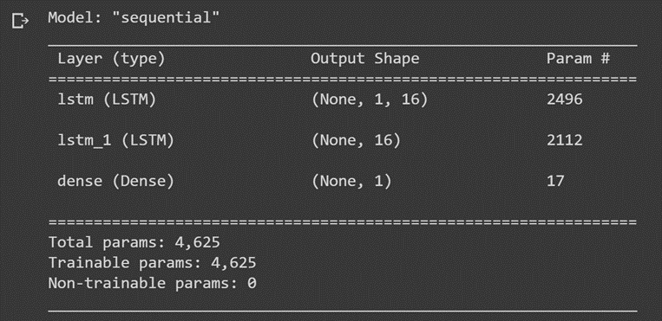

The plot below indicates that the model exhibits a good fit where training and validation losses decrease to a point of stability and there is minimal gap between the two values.

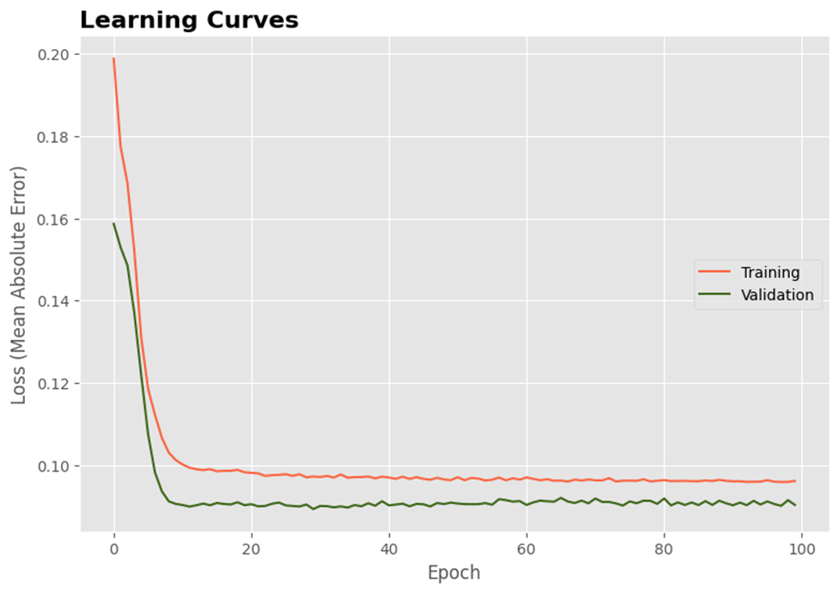

## 

## Forecasting With LSTM

## Forecasting is performed using the trained model and on the data that was not included during the training/validation process. Forecasts and actual values are inverted back into their original scales before calculating error scores for the model. Two error metrics are considered in the forecast evaluation: (1) mean absolute error, and (2) root mean squared error.

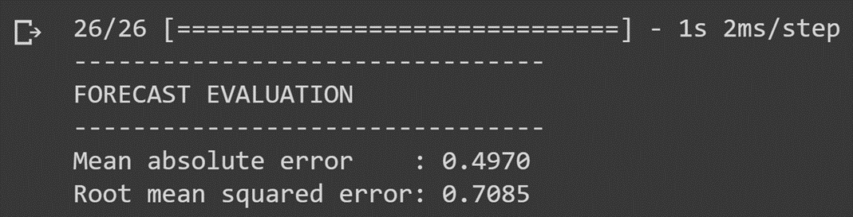

## 

## 

## 

## A comparison of forecasts and actual values of % silica in concentrate is displayed above for the period between 1 a.m. August 8, 2017 and 11 p.m. September 9, 2017. The forecasts largely follow the pattern of actual values and are contained within the 95% confidence interval.

## Forecasting With Random Forest

A random forest regressor, in comparison to LSTM, generates greater error and may not perform as well for long-term forecast.

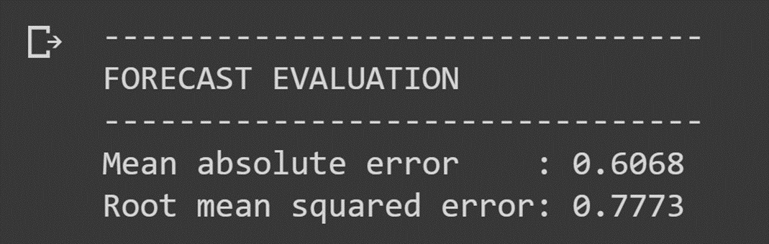

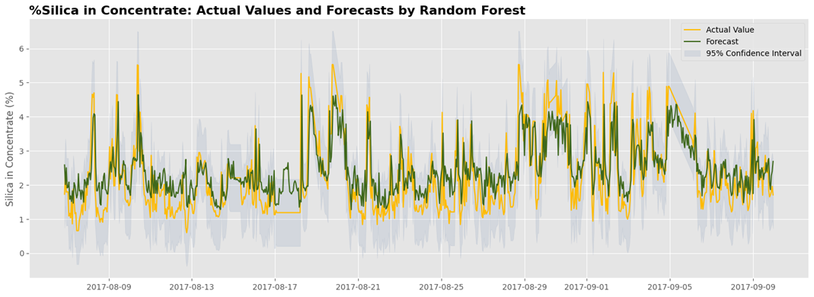

Deep learning approach using LSTM was implemented to forecast gangue content in flotation concentrate.

## Excluding % iron in concentrate from the features, % silica in concentrate were forecasted one hour ahead and with error below 1 (based on RMSE, MAE). As per the dataset MAE and RMSE of 1±0.2 is a satisfactory result. The forecasts thus show a promising method for the engineers to make timely assessments of concentrated purity and take corrective actions in advance, especially when purity deviates from the acceptable values.

**PREDICTION OF % SILICA CONCENTRATE WITH AND WITHOUT USING % IRON CONCENTRATE COLUMN**

Here we looked at the preliminary information regarding the data set such as range, data type and memory usage before proceeding towards the operations of preprocessing and performed checks to make sure that there are 0 null values.

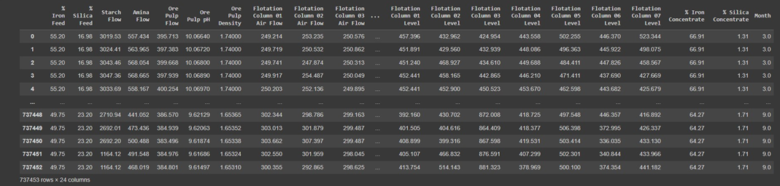

## We replaced the “ , “ symbol to “ . “ for our understanding thereby modifying the date column in the dataset such that only the year and month are displayed separately in individual columns and also dropping the previously present date column. We then converted from string datatype to float.

A correlation analysis was employed in this study to examine if explanatory variables share the same linear relationship with the outcome variable in order to detect duplications of variables in the dataset. Amongst other things, highly correlations between variables were observed in the dataset. The Pearson correlation coefficient r, takes a range of values between +1 to -1. A value of 0 indicates that there is no relationship between the two variables. A value less than zero indicates a negative relationship and a value greater than zero connotes a positive association: that is, as one unit of variable increases, so does the value of the other variable.

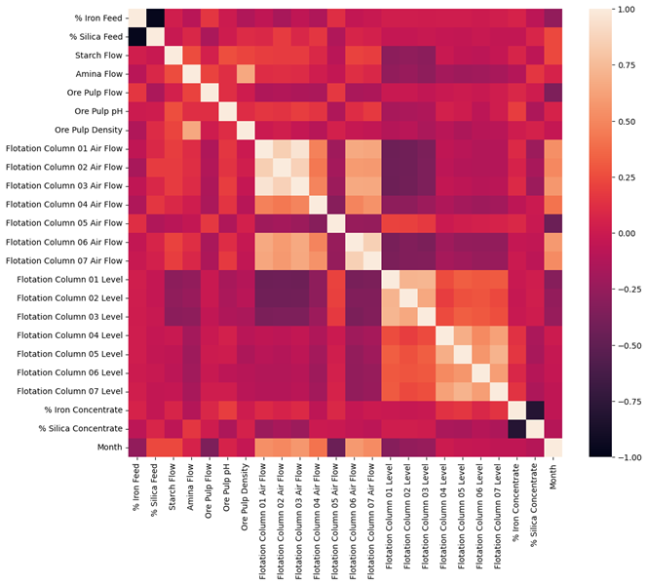

Here We can clearly see that % Silica Concentration and % Iron Concentration are highly correlated.

As we are instructed to check the correlation of % Iron Concentrate with % Silica Concentrate and the possibility of predicting % Silica Concentrate without using % Iron Concentrate we are performing splitting and scaling operation where:

* Y represents % Silica Concentrate which is our target
* X_n represents dataset without % Iron Concentrate
* X_i represents dataset with % Iron Concentrate

Two models are created with Linear Regression for our provided task where:

* model_n represents model without % Iron Concentrate i.e. Y & X_n
* model_i represents model with % Iron Concentrate i.e. Y & X_i

The Resulting Model Scores are as follows :

* Model without iron R^2 Score: 0.1546976326597751
* Model with iron R^2 Score: 0.6866551340256701

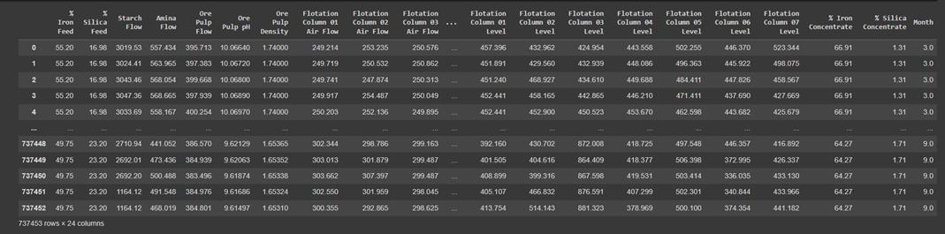

Hence yes it is possible to predict % Silica in Concentrate without using % Iron Concentrate column.

But here we also observe that the R^2 value with inclusion of % Iron Concentrate column is greater than when not included, which means it did really help in the prediction because of the high correlation between them .

## 

## 

## 

## 

## 

## **5.1 High Level Diagram**

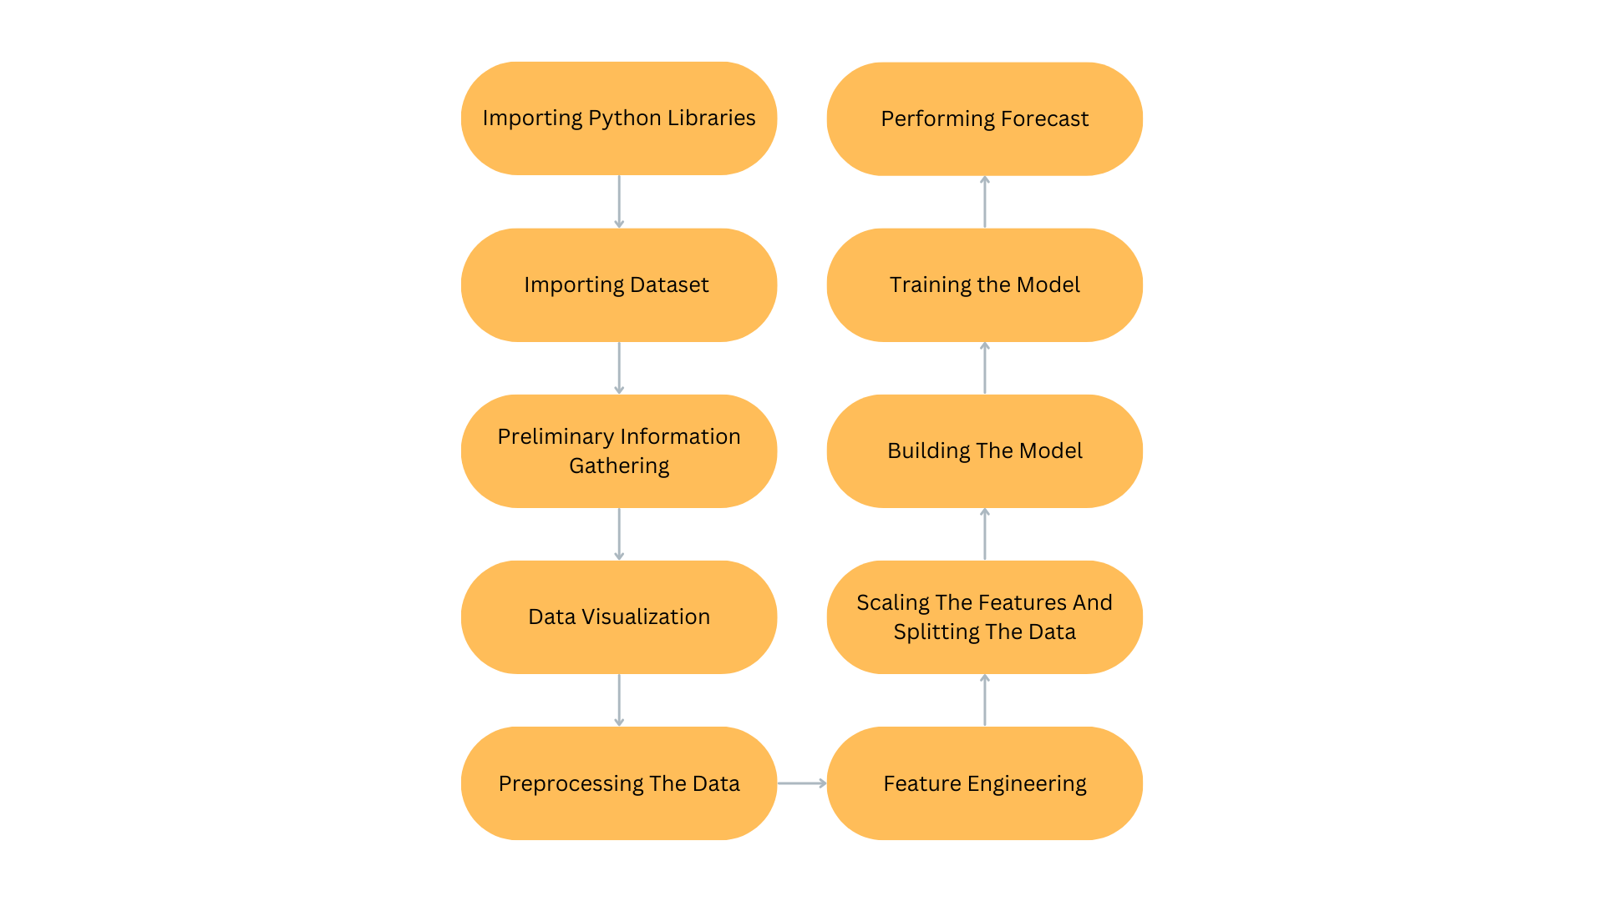

**6 Performance Test**

In the context of predicting % Silica concentration in a mineral processing plant, we conducted computations and calculations utilizing 12 GB of system RAM and 50 GB of hard drive disk space. The goal was to analyze the correlation between % Silica and % Iron and forecast the % Silica with minimum error using a dataset obtained from the mineral processing plant and hence it was achieved.

**6.1 Test Plan/ Test Cases**

* For % Silica concentrate every minute test_size=0.3
* For % Silica concentrate forecast time calculation n_train=0.6, n_valid=0.2 and n_test=0.2
* For prediction of % Silica concentrate with and without using % Iron concentrate column train_size=0.7

## 

## **6.2 Test Procedure**

The whole python code has been implemented on Google Colab that is on an interactive python notebook hence we connect to the resources provided by google colaboratory and then we start by running the code cells present in the .ipynb file. We start off by importing the python libraries which will be required throughout the code which include numpy, pandas, seaborn, matplotlib.pyplot, re, tensorflow, sklearn and IPython then we applied python statistical capabilities to understand the global landscape of the dataset thereby also for data visualization and analyzing of the data which was followed by feature engineering, scaling the features and splitting the data. After these steps we began to build and train models as per our requirement and henceforth were able to provide the desired outcome.

## **6.3 Performance Outcome**

The forecasts largely follow the pattern of actual values and are contained within the 95% confidence interval and when excluding % iron in concentrate from the features, % silica in concentrate were forecasted one hour ahead and with error below 1 (based on RMSE, MAE). As per the dataset MAE and RMSE of 1±0.2 is a satisfactory result. The forecasts thus show a promising method for the engineers to make timely assessments of concentrated purity and take corrective actions in advance, especially when purity deviates from the acceptable values.

**7 My learnings**

Our Learnings in this internship program provided by UpSkill Campus was most importantly the experience of working on a real time industrial data project where we made an attempt to help manufacturing plants to be more efficient thereby expanding our skills and comprehension ability by applying the theoretical knowledge gained throughout the course into this practical project. We also gained experience in the environment in which computer developers and the corporate world works that is constantly enhancing our proficiency in the field along with meeting deadlines and providing desired outcomes.

# **8 Future work scope**

Although our implementation in this experiment has met the objectives which were expected with the submission but it will benefit from further exploration:

* Forecasting with smaller lag timesteps. For example, a 30-minute lag for the features/inputs.
* Analysis of feature importance in order to understand which parameters of the flotation process greatly affect % silica in concentrate. This ensures that the important parameters are adjusted accordingly.
* Reducing the total computation time of the code with higher specification computers which are more optimized to perform the corresponding operations and functions.